**CHAPTER EIGHNT**

**8.0 CSS LINK**

Links can be styled in different ways.

## 8.1 Styling Links

Links can be styled with any CSS property (e.g. color, font-family, background, etc.). In addition, links can be styled differently depending on what **state** they are in.

The four links states are:

* a:link - a normal, unvisited link
* a:visited - a link the user has visited
* a:hover - a link when the user mouses over it
* a:active - a link the moment it is clicked

## Example

<!DOCTYPE html>

<html>

<head>

<style>

/* unvisited link */

a:link {

color: #FF0000;

}

/* visited link */

a:visited {

color: #00FF00;

}

/* mouse over link */

a:hover {

color: #FF00FF;

}

/* selected link */

a:active {

color: #0000FF;

}

</style>

</head>

<body>

<p><b><a href="default.html" target="_blank">This is a link</a></b></p>

<p><b>Note:</b> a:hover MUST come after a:link and a:visited in the CSS definition in order to be effective.</p>

<p><b>Note:</b> a:active MUST come after a:hover in the CSS definition in order to be effective.</p>

</body>

</html>

**Preview:**

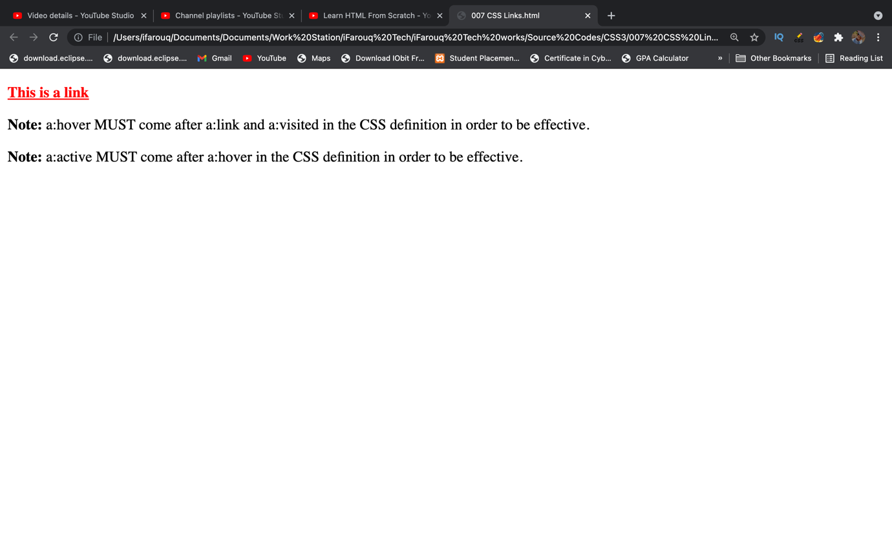

When setting the style for several link states, there are some order rules:

* a:hover MUST come after a:link and a:visited
* a:active MUST come after a:hover

## 8.2 Common Link Styles

In the example above the link changes color depending on what state it is in.

Lets go through some of the other common ways to style links:

## 8.2.1 Text Decoration

The text-decoration property is mostly used to remove underlines from links:

## Example

<!DOCTYPE html>

<html>

<head>

<style>

a:link {

text-decoration: none;

}

a:visited {

text-decoration: none;

}

a:hover {

text-decoration: underline;

}

a:active {

text-decoration: underline;

}

</style>

</head>

<body>

<p><b><a href="default.html" target="_blank">This is a link</a></b></p>

<p><b>Note:</b> a:hover MUST come after a:link and a:visited in the CSS definition in order to be effective.</p>

<p><b>Note:</b> a:active MUST come after a:hover in the CSS definition in order to be effective.</p>

</body>

</html>

**Preview:**

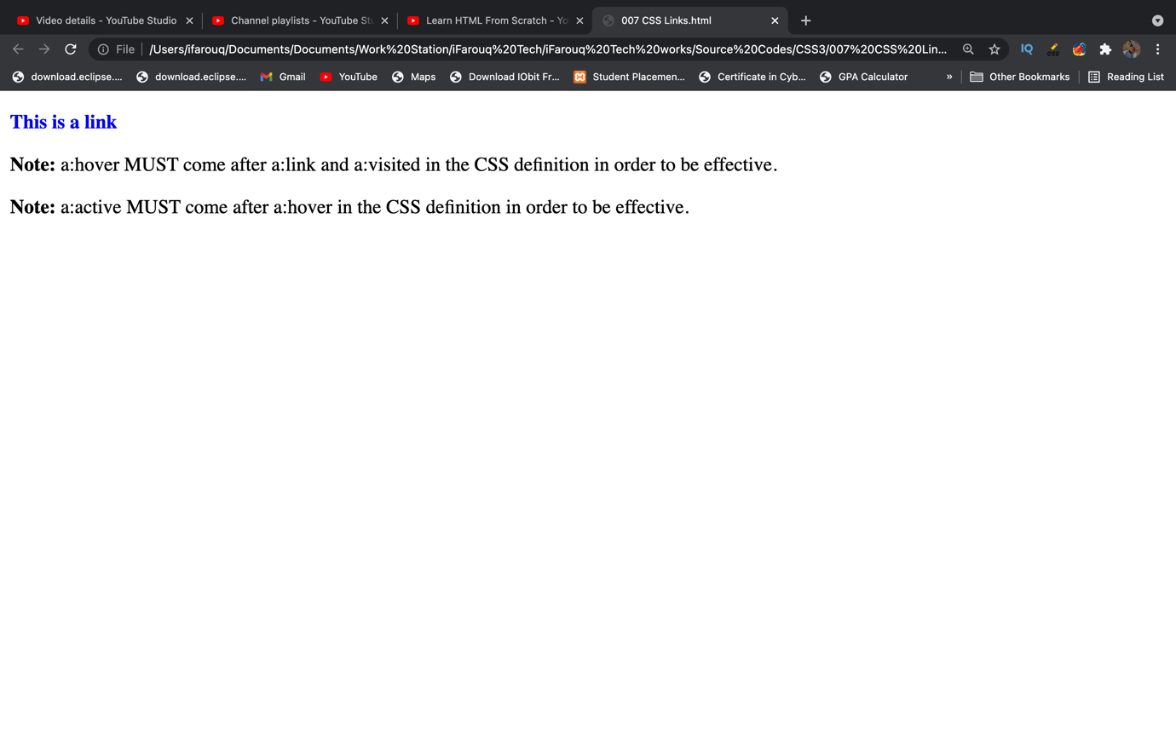

## 8.2.2 Background Color

The background-color property specifies the background color for links:

## Example

<!DOCTYPE html>

<html>

<head>

<style>

a:link {

background-color: #B2FF99;

}

a:visited {

background-color: #FFFF85;

}

a:hover {

background-color: #FF704D;

}

a:active {

background-color: #FF704D;

}

</style>

</head>

<body>

<p><b><a href="default.html" target="_blank">This is a link</a></b></p>

<p><b>Note:</b> a:hover MUST come after a:link and a:visited in the CSS definition in order to be effective.</p>

<p><b>Note:</b> a:active MUST come after a:hover in the CSS definition in order to be effective.</p>

</body>

</html>

**Preview:**

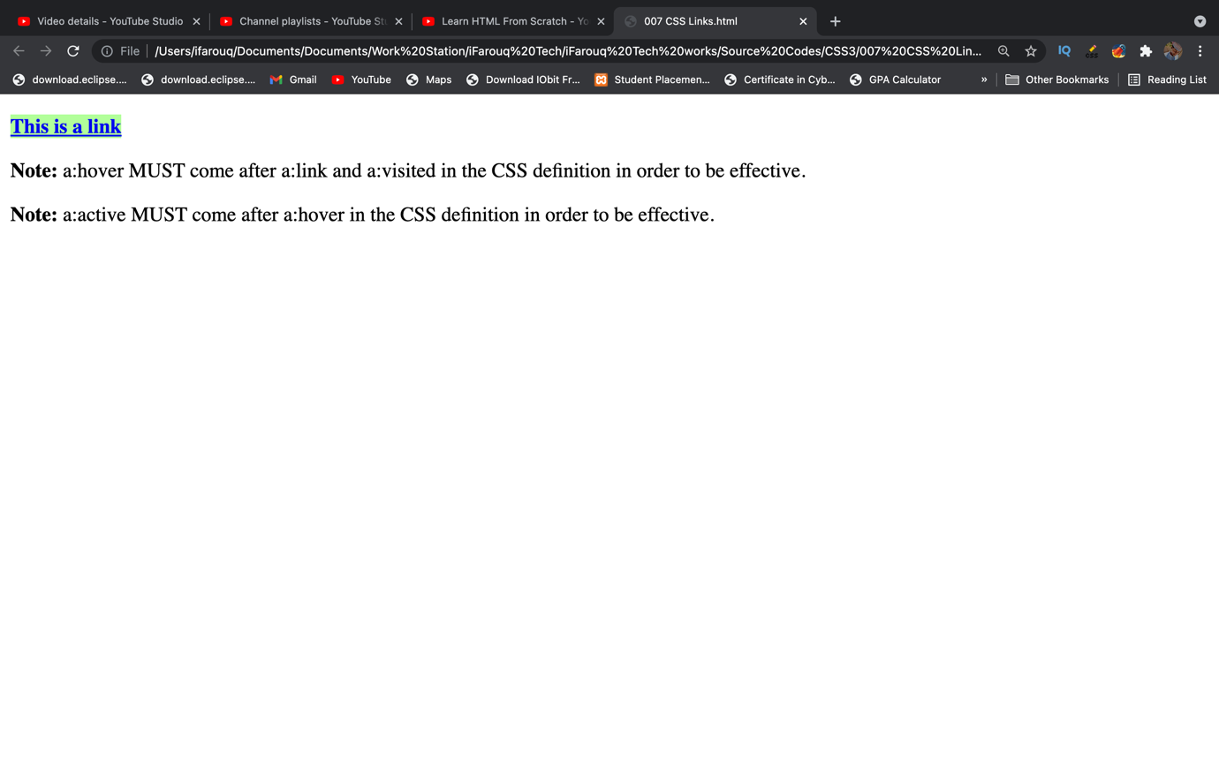

**8.3 Add different styles to hyperlinks**

<!DOCTYPE html>

<html>

<head>

<style>

a.one:link {color:#ff0000;}

a.one:visited {color:#0000ff;}

a.one:hover {color:#ffcc00;}

a.two:link {color:#ff0000;}

a.two:visited {color:#0000ff;}

a.two:hover {font-size:150%;}

a.three:link {color:#ff0000;}

a.three:visited {color:#0000ff;}

a.three:hover {background:#66ff66;}

a.four:link {color:#ff0000;}

a.four:visited {color:#0000ff;}

a.four:hover {font-family:monospace;}

a.five:link {color:#ff0000;text-decoration:none;}

a.five:visited {color:#0000ff;text-decoration:none;}

a.five:hover {text-decoration:underline;}

</style>

</head>

<body>

<p>Mouse over the links and watch them change layout:</p>

<p><b><a class="one" href="default.html" target="_blank">This link changes color</a></b></p>

<p><b><a class="two" href="default.html" target="_blank">This link changes font-size</a></b></p>

<p><b><a class="three" href="default.html" target="_blank">This link changes background-color</a></b></p>

<p><b><a class="four" href="default.html" target="_blank">This link changes font-family</a></b></p>

<p><b><a class="five" href="default.html" target="_blank">This link changes text-decoration</a></b></p>

</body>

</html>

This example demonstrates how to add other styles to hyperlinks.

**Preview:**

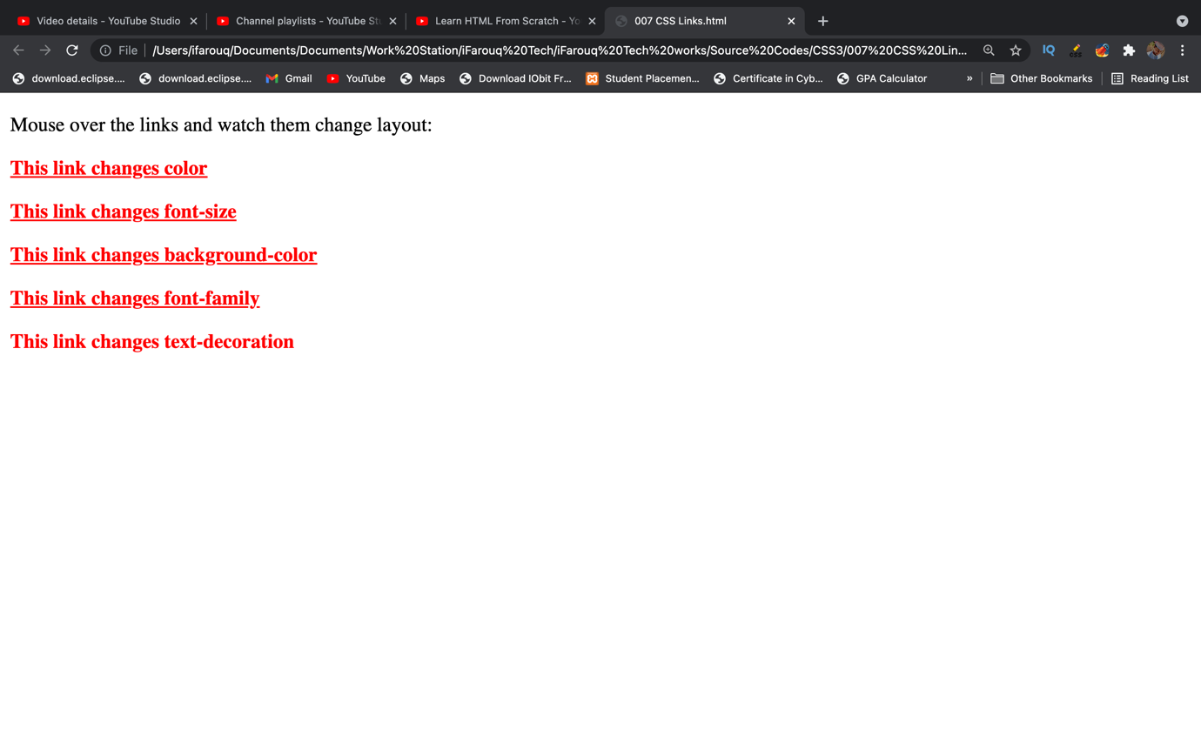

**8.4 Advanced - Create link boxes**

<!DOCTYPE html>

<html>

<head>

<style>

a:link, a:visited {

display: block;

font-weight: bold;

color: #ffffff;

background-color: #98bf21;

width: 120px;

text-align: center;

padding: 4px;

text-decoration: none;

}

a:hover, a:active {

background-color: #7A991A;

}

</style>

</head>

<body>

<a href="default.html" target="_blank">This is a link</a>

</body>

</html>

This example demonstrates a more advanced example where we combine several CSS properties to display links as boxes.

**Preview:**

